**Report on Participation at Conference of Parties 29 (COP29) based in Baku, Azerbaijan**

This report outlines experiences and insights gained by funded participant as a representative for the **ARAB YOUTH SUSTAINABLE DEVELOPMENT NETWORK** at COP29, focusing on the crucial negotiations tracks and their implications for Yemen's climate resilience.

|  |  |
| --- | --- |
| **Participant:** | MR. SAEED JAMIL SAEED ABDO ALHAJ |
| **Represented Org.:** | Arab Youth Sustainable Development Network (AYSDN) |
| **Position at Org.:** | Communication and Reporting Officer |
| **Dates of Participation:** | November 14th to November 22nd 2024 |
| **Location:** | Olympic Stadium – Baku, Azerbaijan |
| **Time:** | Unspecified (Time confirmed based on events and sessions of the conference). |

This report has been conducted in a personal capacity at the AYSDN's request.

This report is prepared and conducted by Participant MR. SAEED JAMIL SAEED ABDO ALHAJ on December 9th, 2024.

[saeed.jamil@aysdn.org](mailto:saeed.jamil@aysdn.org)

(+967) 773 934 842

# INTRODUCTION

This report aims to capture participation as a Yemeni representative at the Conference of Parties COP29, specifically highlighting activities undertaken within the negotiation tracks and key takeaways acquired during the conference. The report introduces AYSDN’s contributions to the global discourse around climate adaptation in light of the urgent need for strategies that surpass Yemen's climate challenges. By sharing such experiences and insights, it is hoped to provide valuable recommendations for future initiatives and collaborations that can enhance Yemen's resilience to climate change.

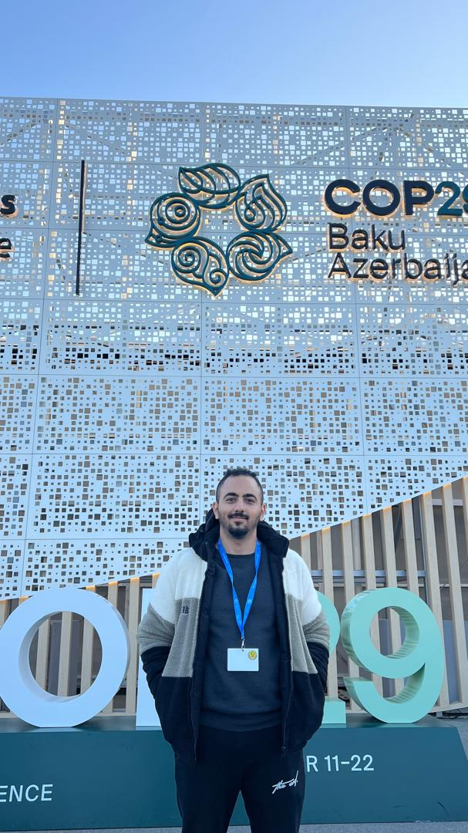COP29, held in Baku, Azerbaijan from 11 to 22 November 2024, served as a key gathering for leaders, negotiators, and stakeholders from around the globe, all united in the fight against climate change. This year's conference was marked by a heightened sense of urgency, as the impacts of climate change increasingly threaten ecosystems, economies, and communities worldwide. The themes of COP29 revolved around enhancing climate adaptation, implementing effective mitigation strategies, and establishing robust financing mechanisms to support vulnerable nations in their efforts to fight climate-related challenges.

The adaptation track followed emerged as a critical platform for sharing innovative solutions and best practices. It provided an opportunity for delegates to discuss various approaches to building resilience, especially in regions like MENA, where climate change worsens and causes vulnerabilities. Discussions through this track highlighted the importance of local knowledge, community engagement, and cross-sectoral collaboration in developing effective adaptation strategies. As a representative, the goal was to advocate for the integration of Yemen's unique challenges regarding climate change into global climate policies and initiatives. *Participant’s Picture of arrival to COP29 on November 14th*

This report highlights key sessions attended, side events participated in, and connections made with other delegates and organizations. By synthesizing these experiences, the importance of international cooperation in addressing climate issues and the specific actions that can be taken to support Yemen's adaptation efforts are demonstrated. Ultimately, this report serves as both a reflection on experiences at COP29 and a call to action for continued support and collaboration in the face of climate change.

# OVERVIEW OF PARTICIPATION

As a Yemeni representative at COP29, the primary role involved representing the interests and challenges faced by Yemen in the context of climate adaptation. Arriving late to the conference allowed for following up with adaptation’s latest negotiation updates virtually until participation in live negotiation sessions. Responsibilities included actively engaging in discussions, collaborating with other delegates facing similar concerns, such as Lebanon and Syria, and advocating for policies that address the unique vulnerabilities of Yemen. A key element in addressing Yemen’s primary challenges through adaptation was participation in the G77+China Group to discuss mutual concerns. Moreover, a significant goal through the negotiation process was to communicate the urgent need for international support and collaboration to enhance Yemen's adaptive capacity, especially in confronting the multi-faceted impacts of climate change.

The adaptation track was of principal importance during COP29, especially for developing countries like Yemen that are on the front lines of climate change. Yemen faces significant threats from rising temperatures, erratic rainfall, and extreme weather events, which intensify existing social and economic challenges. In this context, adaptation is not just a strategy; it is a necessity for the survival and resilience of communities across the country. By focusing on adaptation, actions that support sustainable development, protect livelihoods, and safeguard vital ecosystems can be prioritized.

Throughout the conference, discussions with other delegation teams emphasized the relevance of adaptation strategies to Yemen's specific conditions, highlighting the need for localized solutions that involve community participation and indigenous knowledge. Engaging with other delegates and sharing Yemen’s experiences facilitated a rich exchange of ideas and best practices that can potentially inform future adaptation initiatives. Participation in the adaptation track, despite arriving two days late, underscored the collective responsibility shared in addressing climate change, making it clear that the voices of vulnerable nations, especially Yemen, must be central to global discussions and decision-making processes.

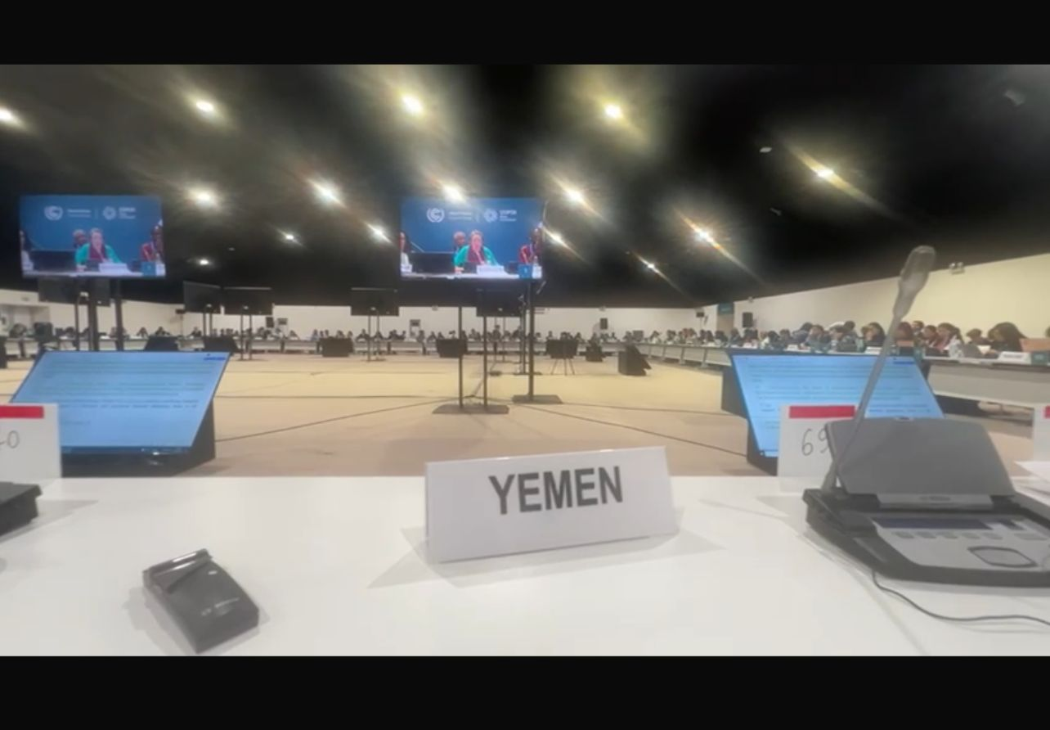

# KEY ACTIVITIES

#### **Sessions Attended**

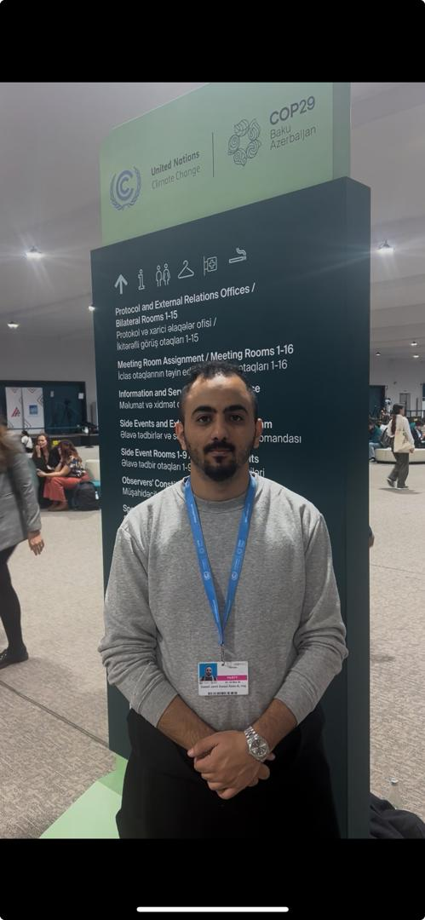During COP29, several key sessions and meetings focused on the adaptation track were attended, including plenaries, contact groups, informal informals, and huddles. Each session contributed to a deeper understanding of the challenges and opportunities facing vulnerable nations. Notably, participation in discussions led by the G77+China Group emphasized the collective responsibility of developing nations to advocate for equitable climate solutions. Key speakers highlighted the urgent need for financial support and technology transfer to boost adaptation efforts in these countries.

|  |
| --- |
| *Participant during a video interview AYSDN on latest updates of adaptation review framework* |

Additionally, sessions organized by the Arab Group were attended, where representatives shared their regional experiences. and strategies for addressing climate impacts. Topics discussed during these sessions included water scarcity, food security, and the necessity for collaborative regional approaches to adaptation. The insights shared were invaluable in framing Yemen's specific needs within a broader regional context.

#### **Side Events**

Besides negotiation meetings and sessions, participation in several side events provided additional perspectives on the climate challenges facing Yemen. One particularly impactful panel discussion focused on floods and food security in Yemen, where experts addressed the increasing frequency of extreme weather events and their implications for agricultural productivity. This discussion panel highlighted innovative approaches to enhancing food security, including sustainable farming practices and improved irrigation techniques.

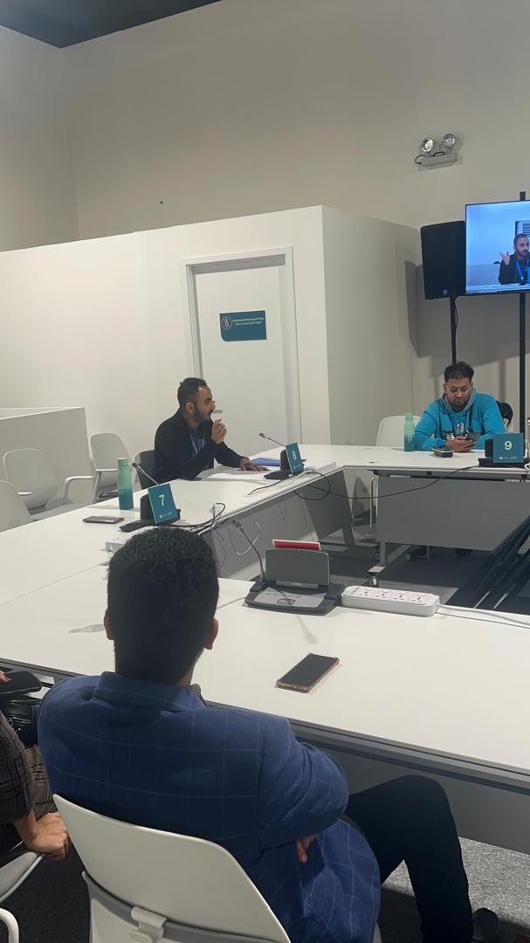 During the Q&A session, engagement with panelists fostered a rich dialogue on expected solutions and joint efforts. This exchange underlined the importance of integrating local knowledge into adaptation strategies and emphasized the need for continued international support, especially for developing countries in the MENA region during climate disasters.

|  |
| --- |
| *Participant’s discussion during a panel discussion on floods and food security in Yemen* |

Additionally, a session focused on climate justice and its impact on future climate negotiations was attended. This session explored how equity and justice considerations are increasingly shaping the discourse around climate action, particularly for vulnerable nations. Key speakers emphasized the obligation to include marginalized voices in negotiations to ensure that policies are fair and effective for all. Case studies were discussed that illustrated how climate justice principles have influenced international agreements, highlighting the importance of recognizing responsibilities in addressing climate change. This session 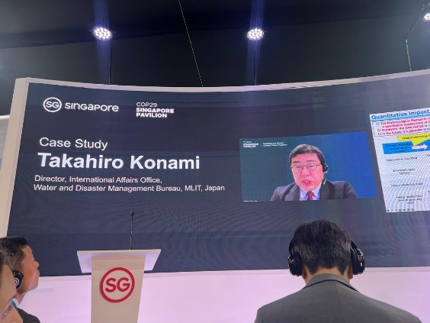contributed to a deeper understanding of the intersection of justice and climate action. The understanding of the critical role that justice plays in securing meaningful outcomes for the voices unheard like Yemen and underscored the need for complete approaches in future climate discussions.

|  |
| --- |
| *A case study presentation conducted by Singaporean Government to addressing sea-rising levels in coastal areas* |

Another panel discussion focused on the vision of developed countries, especially the United States and Canada, regarding the use of nuclear energy as a potential replacement for fossil fuels. This discussion highlighted the growing interest in nuclear energy as a clean alternative in the fight against climate change. Panelists presented various perspectives on the benefits and challenges of nuclear power, including its potential to reduce greenhouse gas emissions (GHGs) and the concerns surrounding safety and waste management.

#### **Pavilions Visited**

Throughout the conference, several pavilions were visited that showcased creative solutions and initiatives related to climate change matters. The Singaporean pavilion, for example, presented cutting-edge strategies for addressing rising sea levels, emphasizing urban resilience and sustainable infrastructure development. Their approach to integrating nature-based solutions into urban planning was particularly inspiring.

At the UNDP pavilion, one of the discussions centered on youth involvement and capacity building in climate action. The emphasis on empowering young people as advocates for sustainable practices resonated with me, as it aligns with the need to engage the next generation in Yemen’s climate resilience efforts.

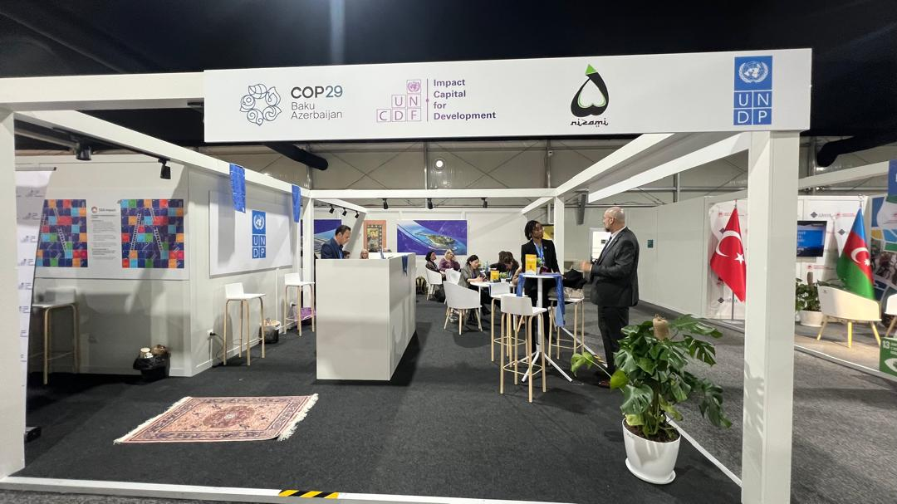

|  |
| --- |
| *UNDP Pavilion after the end of youth involvement presentation and session* |

The Azerbaijani pavilion highlighted the importance of alternative energy sources and reducing reliance on fossil fuels. Their initiatives demonstrated how transitioning to renewable energy can enhance national resilience while contributing to global climate goals. Other pavilions visited focused on raising awareness and envisioning a sustainable future, showcasing various grassroots initiatives and community-based projects. These interactions provided valuable insights into the diverse approaches being taken globally, reinforcing the importance of collaboration and knowledge sharing in the collective fight against climate change.

Due to arriving two days late at COP29, several sessions that were hoped to be attended were regrettably missed, especially the opening plenary on the first day of the conference, which would have further enriched contributions to the adaptation track from the beginning. There was particular disappointment in missing the closing plenary of the conference, as it was believed to provide valuable insights into the outcomes and commitments made during the event. Unfortunately, travel back was necessary a day before the closing session, which limited the ability to engage fully with the final discussions and collaborative opportunities presented at the conference. Despite this setback, efforts were made to maximize participation in the sessions and events that could be attended.

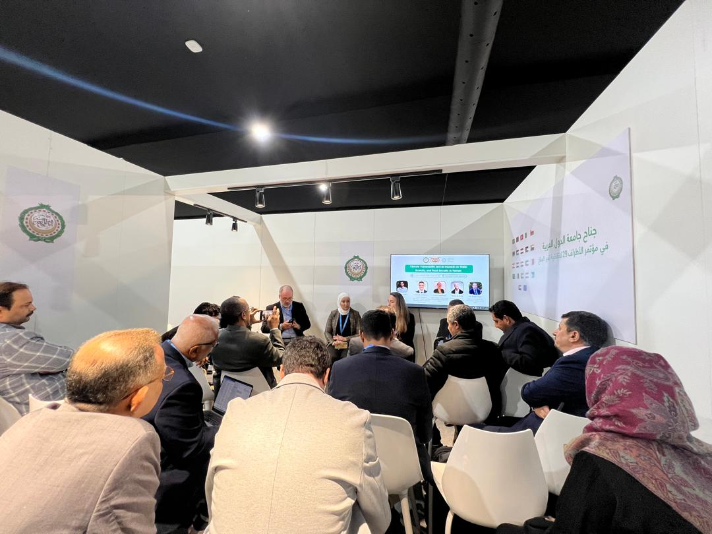

|  |
| --- |
| *League of Arab States during a panel discussion on impacts of water scarcity in MENA Region specifically in Yemen* |

# PERSONAL REFLECTIONS

Attending COP29 provided a profound learning experience that expanded understanding of the complex challenges Yemen faces in the realm of climate adaptation. Discussions on climate justice, food security, and innovative solutions presented by various countries emphasized the pressing need for strategies that address Yemen's unique vulnerabilities and concerns. Valuable insights were gained into how other nations are successfully implementing adaptation measures, sparking ideas for potential applications in Yemen. Furthermore, the importance of community engagement and local knowledge in developing effective strategies became especially clear, reinforcing the notion that successful adaptation efforts must be inclusive and context-specific.

Experiences at COP29 will significantly influence future work and advocacy efforts. Engaging with a diverse range of stakeholders and learning from their approaches will inform strategies for promoting climate resilience in Yemen. Plans include leveraging connections made during the conference to foster collaborations that can bring international support and sustainable solutions to adaptation challenges. Additionally, the emphasis on youth involvement and capacity building will guide efforts to empower the next generation of climate leaders in Yemen, ensuring they have the tools and knowledge necessary to advocate for sustainable practices and policies. Overall, the insights and experiences gained at COP29 will support the ongoing commitment to advancing Yemen’s climate adaptation agenda.

# CONCLUSION

In conclusion, participation as a Yemeni representative of AYSDN at COP29 provided an invaluable experience that enhanced understanding of the pressing challenges and opportunities related to climate adaptation and other negotiation tracks. Through active engagement in sessions, side events, and networking opportunities, critical insights were gained into innovative strategies applicable to Yemen's unique climate context. Discussions on various climate aspects, such as climate justice, youth involvement, and community-based approaches, emphasized the importance of inclusive and equitable solutions in the fight against climate change.

Given Yemen's significant vulnerabilities, it is essential to leverage the knowledge and connections established at COP29 to advocate for enhanced support and collaboration in adaptation efforts. The recommendations outlined in this report aim to empower future delegates and provide actionable steps for the funded unit to strengthen climate resilience in Yemen. By fostering a practical and informed approach, it can be ensured that Yemen's needs are addressed within the global climate framework, ultimately contributing to a more sustainable and secure future for communities. A commitment to applying the insights gained from this conference will advance the climate adaptation agenda and continue advocating for the voices of vulnerable nations in international discussions.

***